**Binary Search Tree Contact Management**

**Introduction:**

A phonebook management system is an essential application for storing and retrieving contact information. This project aims to create a basic yet functional phonebook management application using the Qt framework, which will allow users to manage their contacts easily and intuitively. The system is designed to simplify the process of saving, viewing, and organizing contact details for individuals, making it suitable for personal and professional use.

**Project Scope:**

The Phonebook Management System is a comprehensive application designed to efficiently manage contacts. Its core functionalities include:

1. **Adding New Contacts:** Allows users to input and securely store contact details.
2. **Modifying Existing Contacts:** Provides options to update information for stored contacts.
3. **Deleting Contacts:** Enables the removal of selected contacts from the system.
4. **Searching Contacts:** Offers multiple search criteria (e.g., phone number, name, email) to quickly locate specific contacts.

In addition to contact management, this project features separate **visualization tools** for various tree data structures. **Binary Search Tree (BST), AVL Tree, and Red-Black Tree (RBT) visualizers** are included, providing an interactive, educational experience allowing users to explore and understand data structures independently.

**Technologies Used:**

* **Qt Framework:** We used the Qt framework for developing the graphical user interface (GUI) of the application due to its flexibility and cross-platform capabilities.
* **Programming Language:** C++ was used to implement the logic of the application.

**Development Tools Used:**

* **IDE:** Qt Creator
* **Compiler:** GCC for C++ (or any compatible compiler)

**UI Design:**

The application was designed with a simple and clean UI. Key screens include:

1. Main Window
2. Binary Search Tree
3. AVL Tree
4. Red Black Tree
5. PhoneBook

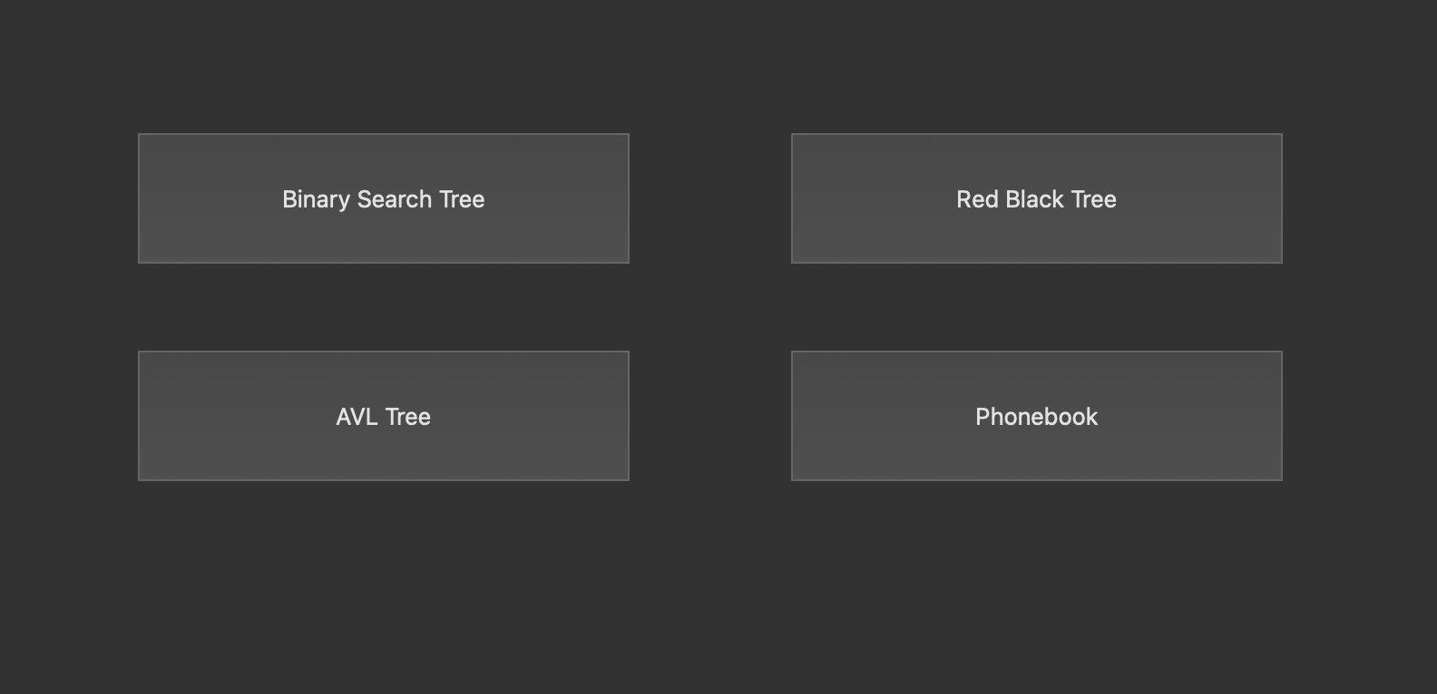

**Module Breakdown:**

The main window of the program contains 4 modules:

1. Binary Search Tree:
   1. Insert Function
   2. Delete Function
   3. Traversal function (Inorder, Pre-order, Post-order)

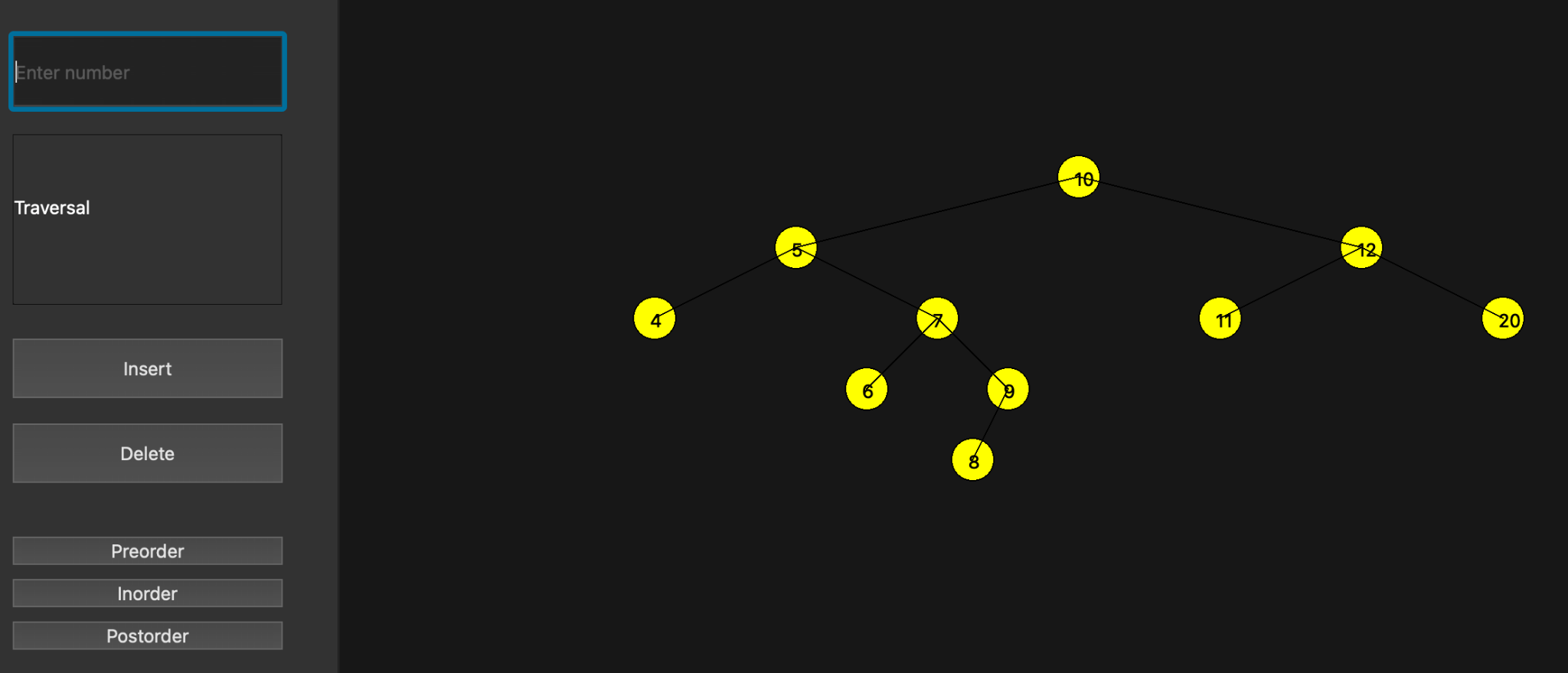

1. AVL Search Tree:
   1. Insert Function
   2. Delete Function
   3. Traversal function (Inorder, Pre-order, Post-order)
   4. Height balanced

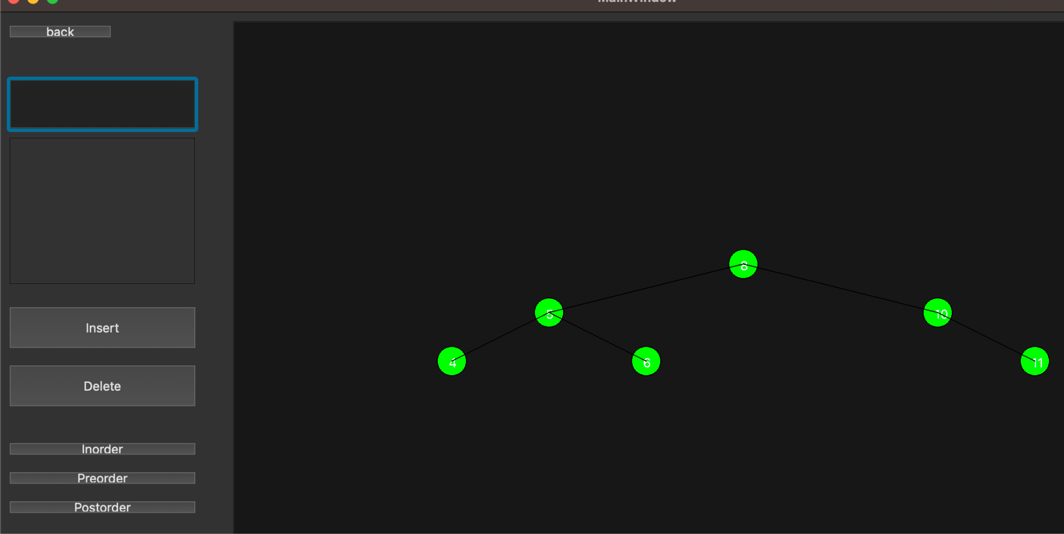

1. Red Black Tree:
   1. Insert Function
   2. Delete Function
   3. Traversal function (Inorder, Pre-order, Post-order)
   4. Color height balanced

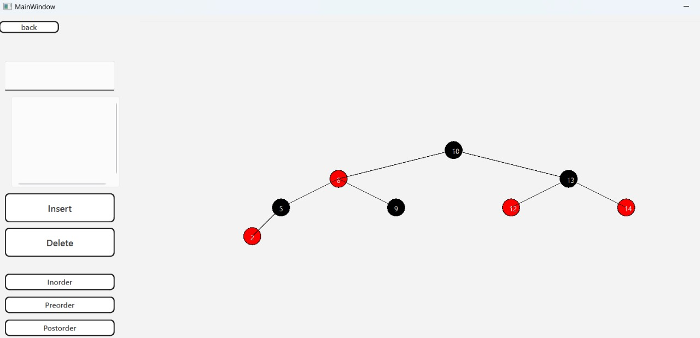

1. PhoneBook:
   1. Insert Function
   2. Delete Function
   3. Search by Number
   4. Search by Name
   5. Show contact list
   6. Show Binary Search Tree

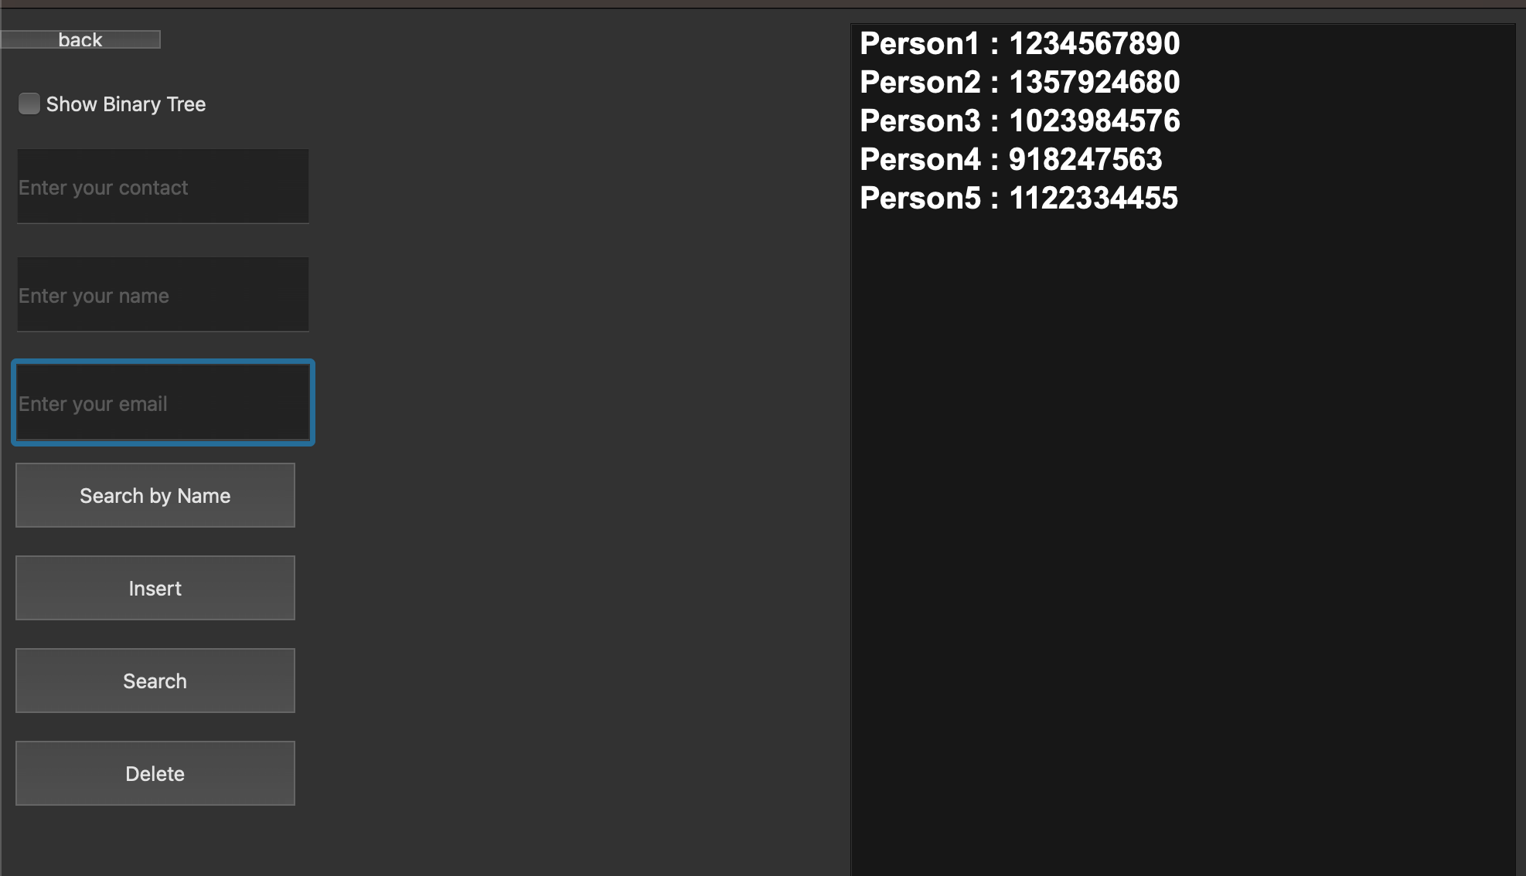

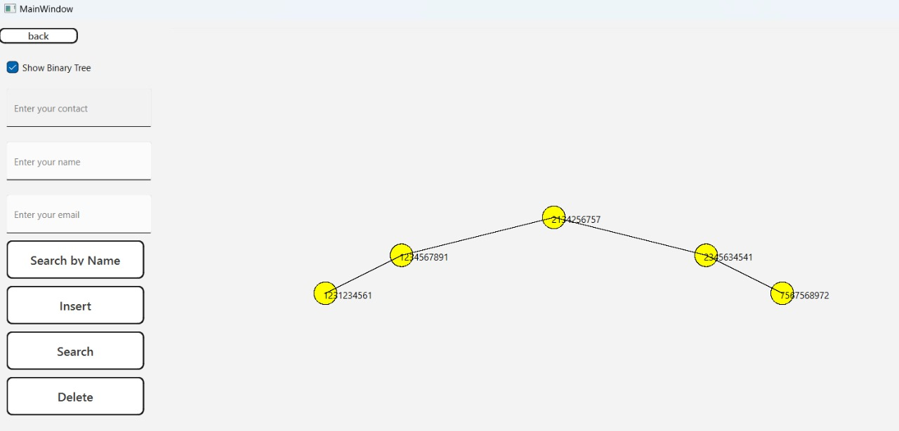

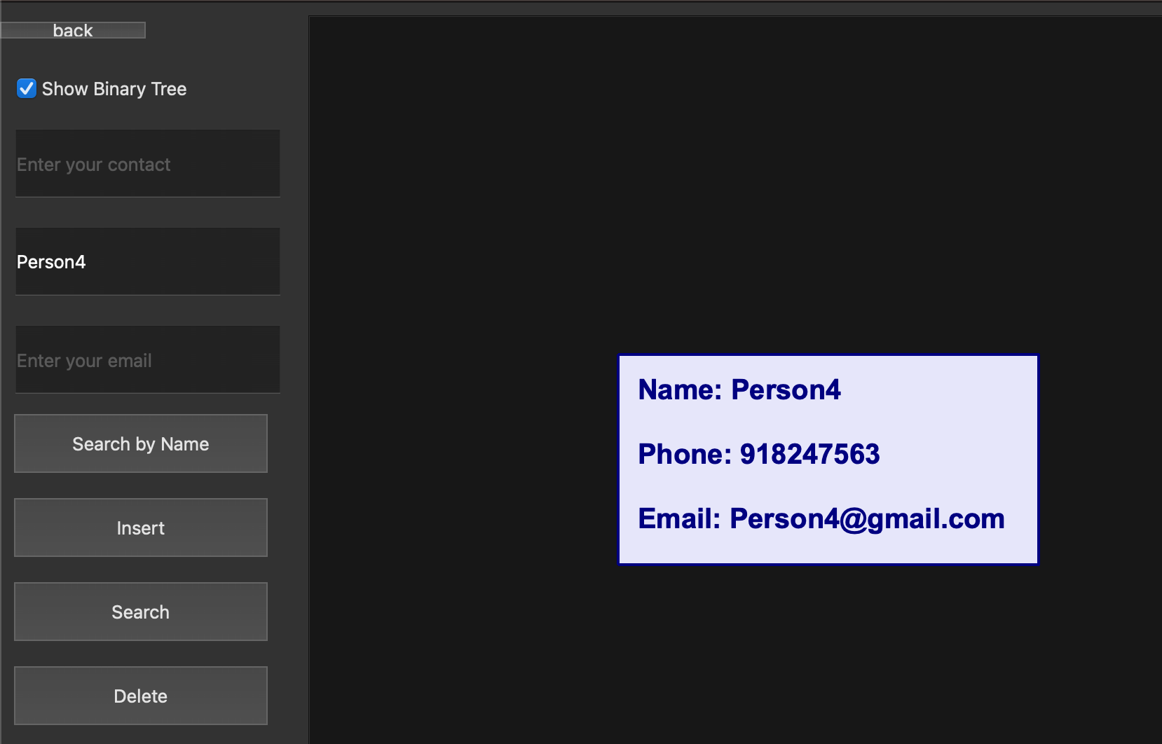

**Challenges:**

* **Data Persistence:** Managing data storage for the phonebook was initially challenging, but implementing Binary Search Tree as a data structure helped in providing reliable data storage and retrieval.
* **Search Optimization:** Ensuring fast search results was achieved by implementing optimized search algorithms within the application

**Summary:**

The *Phonebook Management System* provides a functional, user-friendly solution for managing contacts. The application is stable, responsive, and supports essential contact management features. The project successfully demonstrates the power of the c++ and Qt framework in developing cross-platform applications.

**References:**

* Qt Documentation
* C++ Documentation